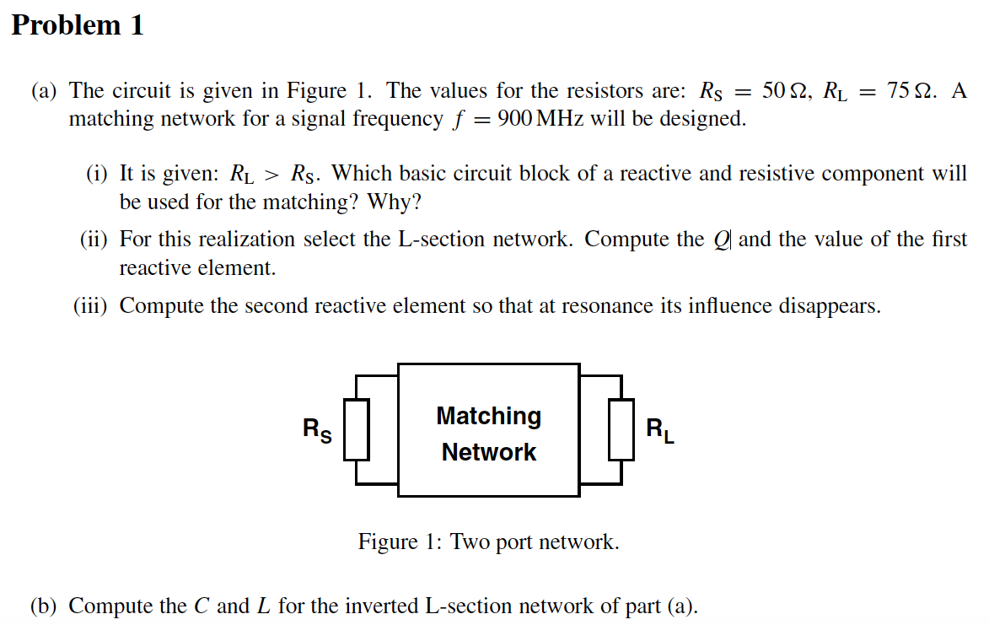

(i)which basic circuit block of a reactive and resistive component will be used for the matching? why?哪种基本的reactive和阻性元件的电路块将被用于匹配。为什么？

答:

电容和电感.

因为电容和电感在高频谐振的时候，电容和电阻是虚部抵消的, 留下实部. rs并不是一个真实的，是个等效的. 将电感L1-RL分支转换为并联部分会产生一个更高的电阻,并联的等效电感大约等于L1，并被C1所抵消。

(ii)For this realization select the L-section network. Compute the Q and the value of the first reactive element. 为了实现这一点，选择L型截面网络。计算第一个无功元素的值和品质因子。

答:

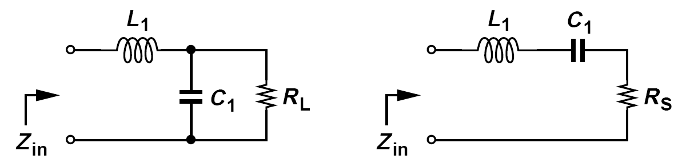

如上图,

从并联变成串联, 电阻变小.

品质因子 75/ (1+Qp平方)= 50

实际上Qp平方 = 0.5

公式为

ω = 2πf

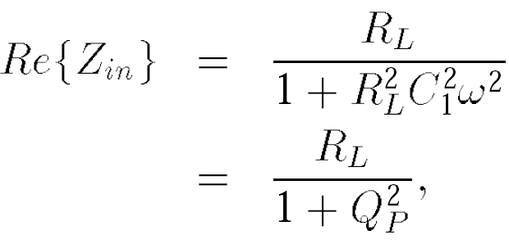

75 *C1 *900 MHz*2π = Qp

C1 = 1.6pF

(iii)Compute the second reactive element so that at resonance its influence disappears. 计算第二个无功元素，让他在共振时其影响消失。

答:

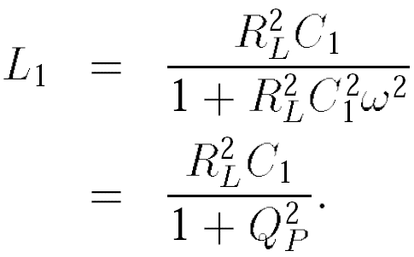 L1 = 75平方* C1 /(1.5) = 6.25nH

(b) Compute the C and L for the inverted L-section network of part (a).

答:

电感和电阻并联 , 并联高频看成串联可以让电阻变小.

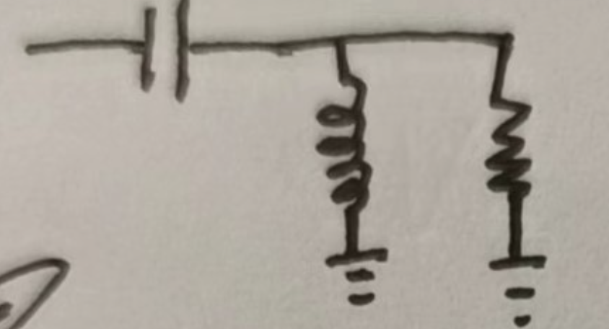 C放前面就是倒L型电路, L放前面就是L型电路.

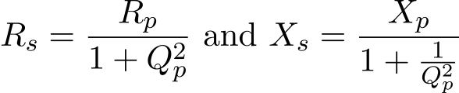 Rs= Rp·Xp2 / (Rp2 + Xp2)

这里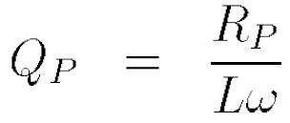, X 为L, Xp 就是Lw

因为Rs = 50,Rp = 75

所以Qp 平方还是0.5

所以可以得到L = Rp *Qp/ w = 9.37nH

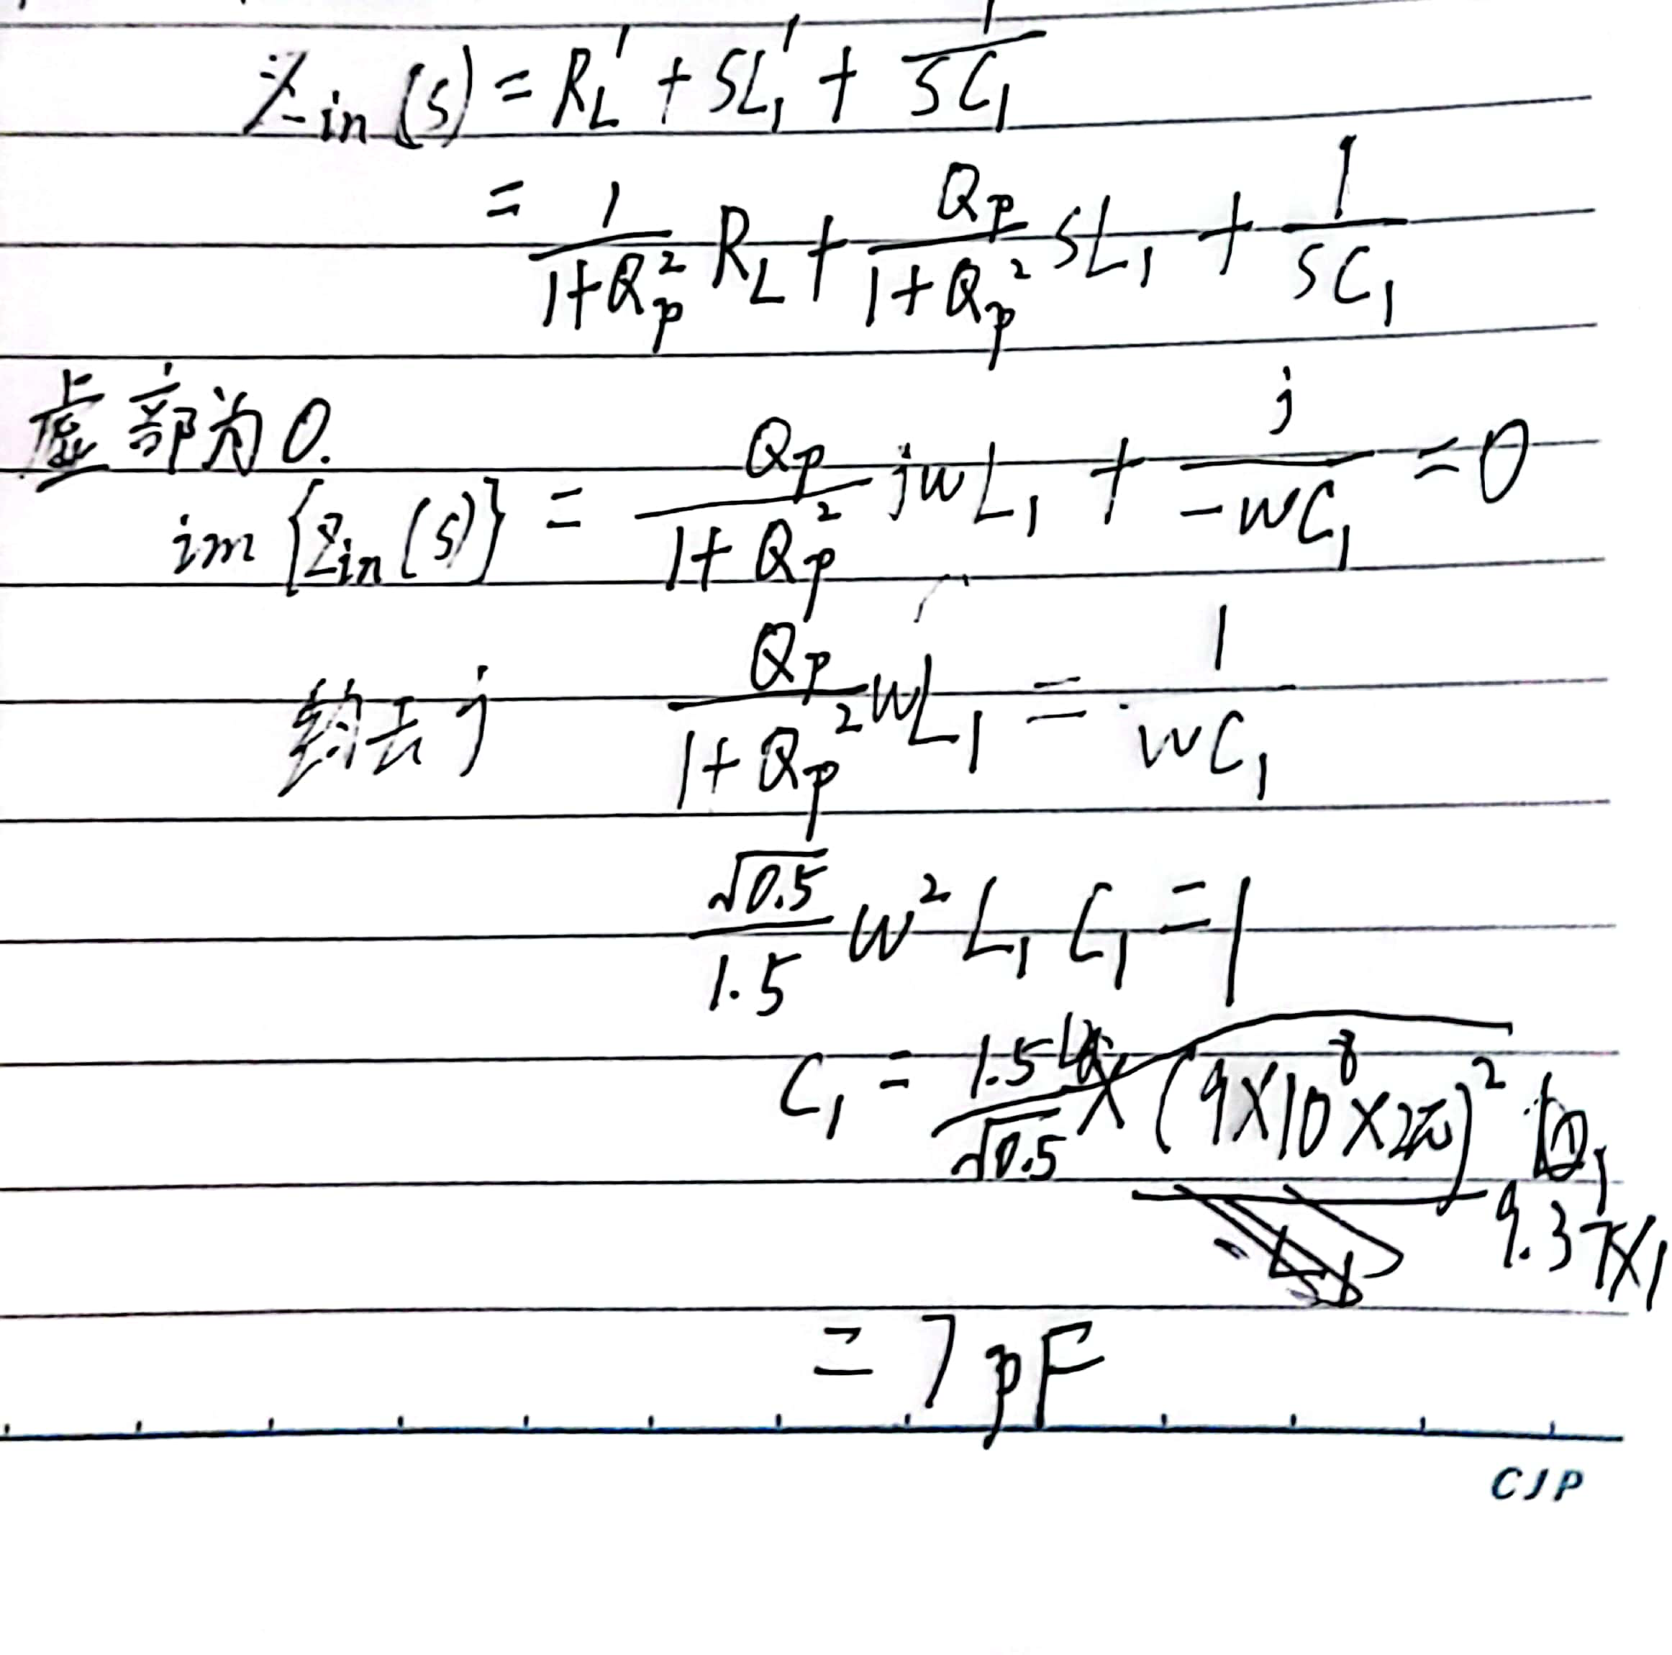

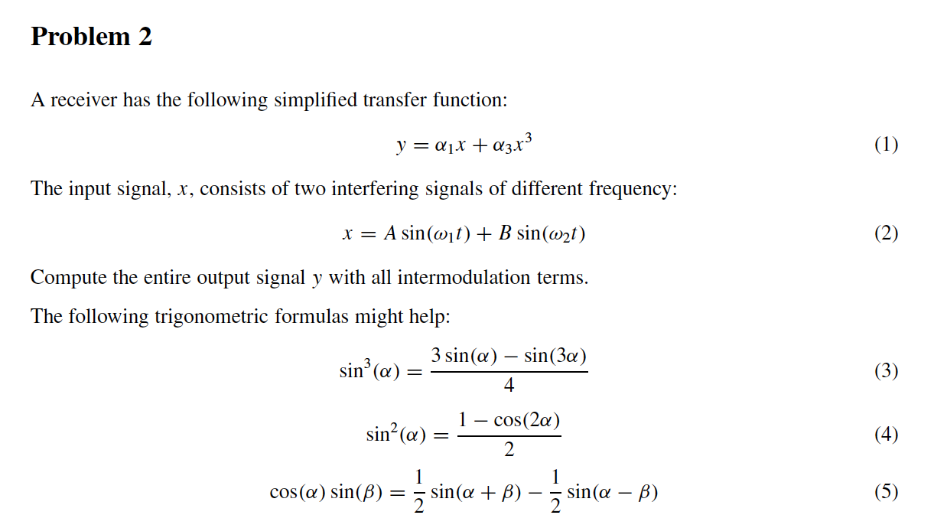

A receiver has the following simplified transfer function:

= a1x+ a3x3 (1)

The input signal, *x,* consists of two interfering signals of different frequency:

Compute the entire output signal y with all inter modulation terms.

答:

如下图

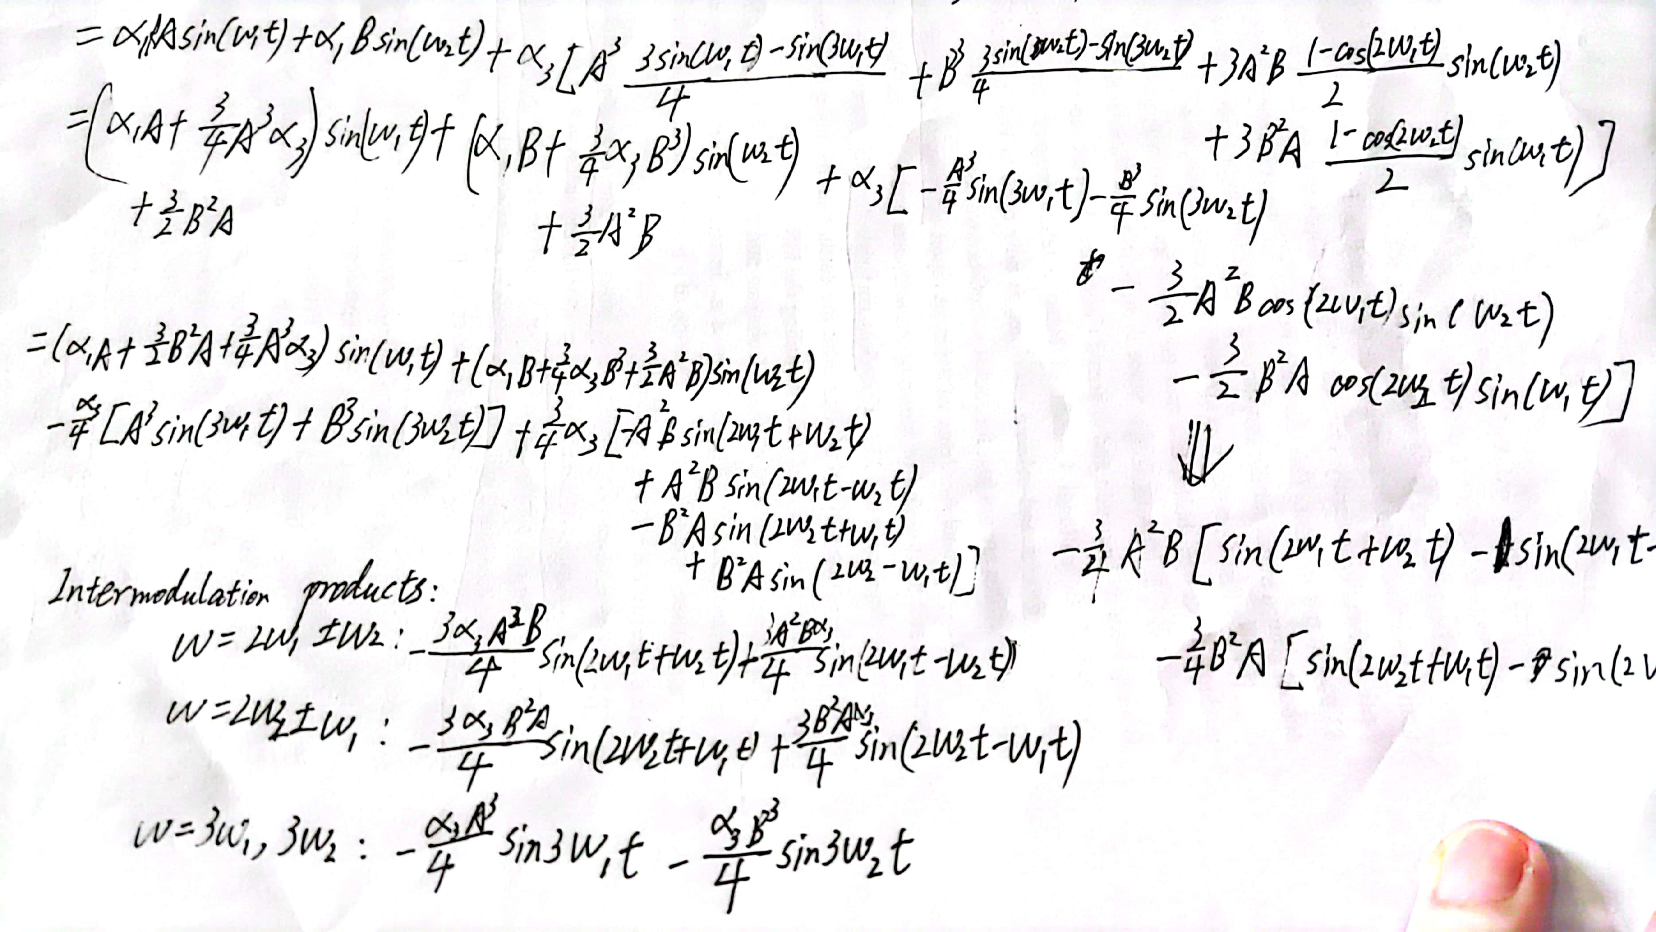

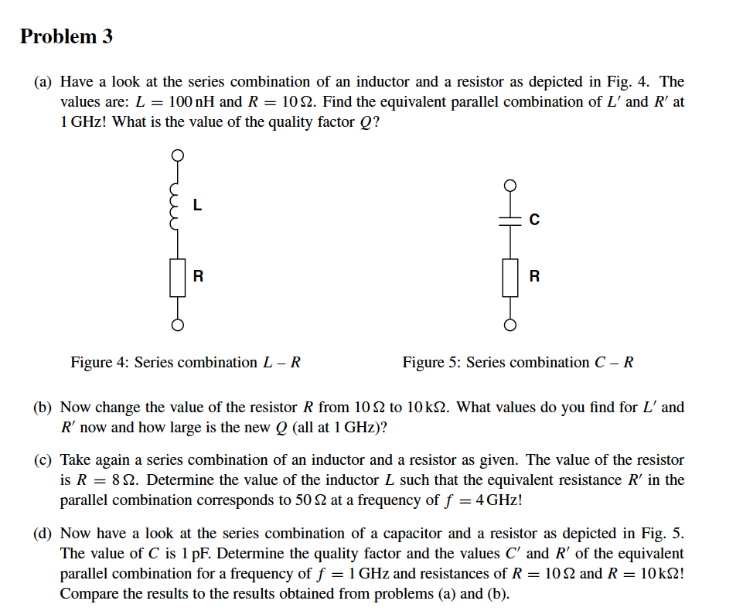

1. Have a look at the series combination of an inductor and a resistor as depicted in Fig. 4. The values are: ***L =*** 100 nH and ***R = 10 欧姆***. Find the equivalent parallel combination of ***L'*** and ***R'*** at 1 GHz! What is the value of the quality factor ***Q?***
2. 请看图4所示的一个电感和一个电阻的串联组合。其数值为。L = 100 nH，R = 10 欧姆。找出L'和R'在1GHz时的等效平行组合! 质量系数Q的值是多少？

答:

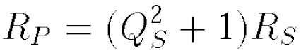

Qs = Lw/Rs = 20π

R‘ = (Lw)平方/Rs + Rs = 39.48K 欧姆

Qs 平方》1 所以L‘ 约等于L = 100nH

1. Now change the value of the resistor ***R*** from 10 to 10 k 欧姆. What values do you find for ***L‘***and ***R'*** now and how large is the new ***Q*** (all at 1 GHz)?

答:



Qs = Lw/Rs = 0.063

R‘ = (Lw)平方/Rs + Rs 约等于10k欧姆 = R

L‘ 等于(Qs平方)/(Qs平方+1) L= 3.95*10E-3 *100 *10E-9 = 0.95nH

1. Take again a series combination of an inductor and a resistor as given. The value of the resistor ***is R =*** 8 欧姆. Determine the value of the inductor ***L*** such that the equivalent resistance ***R'*** in the parallel combination corresponds to 50 欧姆 at a frequency of *f =* 4 GHz

答:

再以一个电感和一个电阻的串联组合为例。电阻器的值是R=8欧姆。确定电感器L的值，以便在f = 4 GHz的频率下，平行组合中的等效电阻R'对应于50欧姆。



Qs = Lw/Rs =

R‘ = (Lw)平方/Rs + Rs 等于50欧姆

Lw平方 = 336

L = 0.7nH

1. Now have a look at the series combination of a capacitor and a resistor as depicted in Fig. 5. The value of *C* is 1 pF. Determine the quality factor and the values C' and ***R'*** of the equivalent parallel combination for a frequency of f = 1 GHz and resistances of ***R = 10 欧姆***and ***R =*** 10 k欧姆, Compare the results to the results obtained from problems (a) and (b).

(d)现在来看看图5中描述的电容和电阻的串联组合。C的值是1 pF。确定频率为f = 1 GHz，电阻为***R = 10 欧姆***and ***R =*** 10 k欧姆, 时，等效并联组合的品质因数以及C'和R'的值，将结果与问题(a)和(b)中得到的结果进行比较。

答:

Xw = 1/Cw

R =10欧姆时

由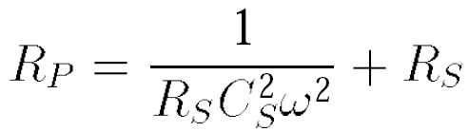

可以得到 R‘ = 10 + 1/(10* 1pf平方 * 1GHz*2pi 平方) = 2543

由

可以得到Qs 平方= 253 , Qs = 15.9

因为Qs》1, 所以C’ = Cs = 1pF

R = 10k欧姆时, 如上公式

R‘ = 10k + 1/(10k* 1pf平方 * 1GHz * 2pi 平方) = 10002 约等于10k

Qs = 0.014

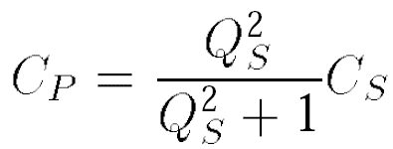

C’ = 0.0002pF